595 Main Street, Aumsville, OR 97325
Office: (503) 749-2030 ~ FAX: (503) 749-1852
Email: rharding@aumsville.us
PUBLIC MEETING NOTICE
CITY COUNCIL MEETING
In the Community Center and via Zoom Video Conference
MONDAY, November 8, 2021
A G E N D A

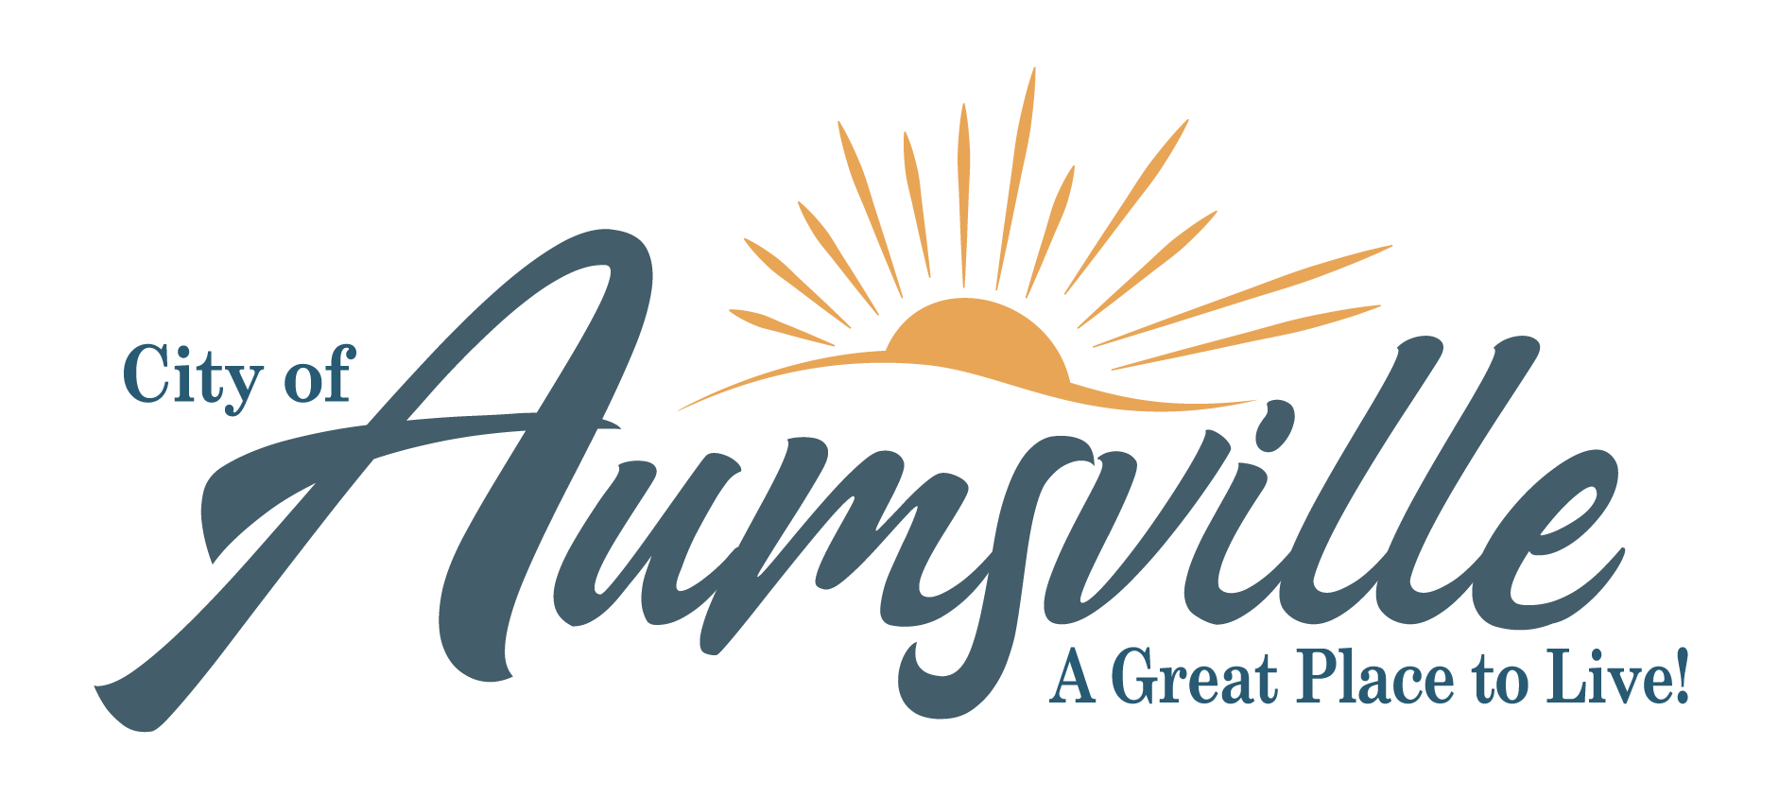

- CALL TO ORDER: 7:00PM
  - Approve Agenda
- PRESENTATIONS, PROCLAMATIONS, & VISITORS
  - Presentation: Water System Presentation – Chris Brugato Westech Engineering
  - Public Comment: Council will conduct the meeting in-person and via Zoom conference call. Public Comment will be accepted from online attendees at this time. Comments are limited to 5 minutes and only for comments on items other than Public Hearings listed below. There is a public comment period within each hearing. You may also submit comments by emailing City Administrator Ron Harding at rharding@aumsville.us by noon on November 8, 2021.
  - Visitors: Visitors can attend in-person or online. For information about how to attend the meeting online, please visit our website https://www.aumsville.us/citycouncil/page/city-council-regular-meeting-78 or email crogers@aumsville.us to request log in instructions.
- CONSENT AGENDA: (Action)
  - October 25, 2021 Council Meeting Minutes
- PUBLIC HEARING: None
- OLD BUSINESS: None
- NEW BUSINESS:
  - Resolution No. 20-21 A RESOLUTION ESTABLISHING UPDATED CITY SERVICE FEES AND PUBLIC RECORDS/ INFORMATION REQUEST POLICY (Action)
  - Affidavit for the Partial Diminution of a Water Right Certificate (Action)
  - Farm Lease Transfer for “Monker’s Place” (Action)
- CITY ADMINISTRATOR REPORT: (Information)
  - Review Check Register October 29, 2021 through November 4, 2021
  - Police Report: Chief Schmitz’ Monthly Report
  - Public Works Report: Director Oslie’s Monthly Report
- MAYOR AND COUNCILORS REPORTS
- GOOD OF THE ORDER: Other Business May Come Before the Council at This Time
- CORRESPONDENCE: None
- EXECUTIVE SESSION: None
- ADJOURNMENT
The City of Aumsville does not and shall not; discriminate on the basis of race, color, religion (creed), gender, gender expression, age, national origin (ancestry), disability, marital status, sexual orientation, or military status, in any of its activities or operations.
Anyone wishing to speak on an agenda item should ask to be recognized by the Mayor or Chair at the beginning of that agenda item. The meeting location is accessible to persons with disabilities. A request for an interpreter for the hearing impaired, or for other accommodations for persons with disabilities must be made at least 48 hours prior to the meeting. Please call (503) 749-2030 and leave a message or Oregon Relay Service for TDD at (800) 735-2900.

