**PUBLIC NOTICE**

**AUMSVILLE CITY COUNCIL MEETING**

Chester Bridges Memorial Community Center

555 Main Street, Aumsville, Oregon 97325

***MONDAY, June 10, 2019***

**Amended A G E N D A**

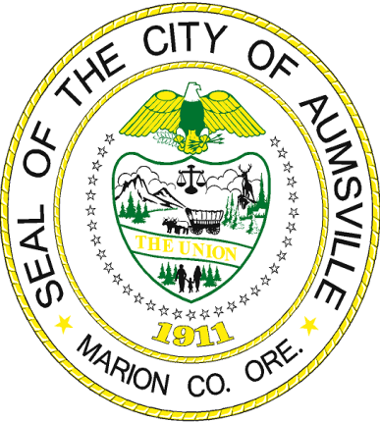

1. **CALL TO ORDER**: **7:00PM**
   1. Pledge of Allegiance
   2. Approve Agenda – With corrections item 4B, Resolution 17-19
2. **PRESENTATIONS, PROCLAMATIONS, & VISITORS** 
   1. **Public Comment** is welcome at this time on agenda items other than public hearings – please limit comments to 3 minutes.
3. **CONSENT** **AGENDA:** 
   1. Review of Bills: May 13, 2019 through May 31, 2019 Check Registers
   2. ACC Meeting May 13, 2019 Minutes
4. **PUBLIC HEARINGS:** 
   1. Open **State Revenue Sharing Hearing**
      1. Staff Report: Finance Officer Hoyer
      2. Receive Public Comments on the Proposed Park Fund’s Use of State Shared Revenue
      3. Discuss Possible Uses of State Revenue Sharing Funds
      4. Close Public Hearing
      5. Council Deliberations
      6. Council Decision:
         1. Resolution No. 15-19 A RESOLUTION CERTIFYING MUNICIPAL SERVICES
         2. Resolution No. 16-19 A RESOLUTION DECLARING THE CITY’S ELECTION TO RECEIVE STATE REVENUES
      7. Close Public Hearing
   2. Open **BUDGET HEARING - Fiscal Year 2019-2020**
      1. Staff Report: Budget Officer Harding / Finance Officer Hoyer
      2. Testimony/Comments Questions
      3. Close Public Hearing
      4. Council Deliberations
      5. Council Decision:
         1. Resolution No. 17-19 A RESOLUTION ADOPTING THE 2019-2020 FISCAL YEAR BUDGET, MAKING APPROPRIATIONS, AND IMPOSING AND
         2. Resolution No. 18-19 A RESOLUTION EXTENDING THE CITY OF AUMSVILLE’S WORKERS’ COMPENSATION COVERAGE TO VOLUNTEERS OF THE CITY OF AUMSVILLE POLICY YEAR 2019-20
      6. Close Public Hearing
5. **OLD BUSINESS: NONE**
6. **NEW BUSINESS: (Action)** Approval of Vactor/Jetting Truck Purchase
7. **CITY ADMINISTRATOR REPORT:**
   1. Police Report: Chief Schmitz’ Monthly Report
   2. Public Works Report: Director Oslie’s Monthly Report
   3. May 15, 2018 Staff Team Meeting Notes
8. **MAYOR AND COUNCILORS** **REPORTS**
9. **GOOD OF THE ORDER:** Other business May Come Before the Council at This Time
10. **CORRESPONDENCE:** LOC Annual Conference September 26-28, 2019
11. **EXECUTIVE SESSION**: **None**
12. **ADJOURNMENT**

The City of Aumsville does not, and shall not; discriminate on the basis of race, color, religion (creed), gender, gender expression, age, national origin (ancestry), disability, marital status, sexual orientation, or military status, in any of its activities or operations.

Anyone wishing to speak on an agenda item should ask to be recognized by the Mayor or Chair at the beginning of that agenda item. The meeting location is accessible to persons with disabilities. A request for an interpreter for the hearing impaired, or for other accommodations for persons with disabilities must be made at least 48 hours prior to the meeting. Please call (503) 749‑2030 and leave a message or Oregon Relay Service for TDD at (800) 735‑2900.